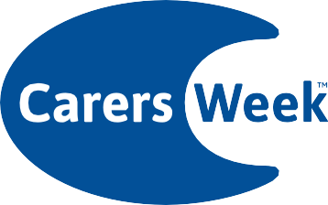
Are you looking after someone?
This Carers Week we’re coming together throughout the UK, drawing attention to how important caring is and helping carers to become healthy and connected.
For more information visit
carersweek.org
© 2018. Carers UK is a charity registered in England and Wales (246329) and in Scotland (SC039307) and a company limited by guarantee 864097. Registered office 20 Great Dover Street, London, SE1 4LX

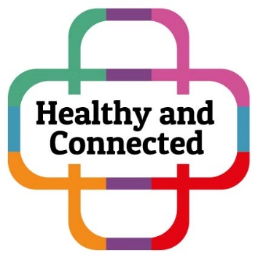

Come Along to the Fire Station Zone in the newly refurbished Middlesbrough Town Hall on Thursday 14th June 2018 from 11:30 to 3:30 pm and help us celebrate Carers Week.

You will find information stalls from a number of Carer Organisations plus an exciting Young Carers Photo Exhibition!

Carers Week is an annual campaign to raise awareness of caring, highlight the challenges carers face and recognise the contribution they make to families and communities throughout the UK.

Carers Week 2018 will focus on ‘Supporting carers to stay healthy and connected’, so that they can look after themselves and their loved ones, whilst recognising that carers are people with needs of their own.

Are you looking after family or friends who are older, ill or who have a disability?
A carer is someone who provides care and support to a parent, relative, a child or friend who has a disability, an age related problem, mental or physical illness or alcohol or drug problems.

Find out more about the information and support available for carers
by contacting your local Adult Carers Service or Carers Together on
01642 488977 or email carerstogether@btconnect.com

For your local Young Carers Service contact The Junction
on 01642 75600 or visit www.thejunctionredcar.com to find out more.

